**DOCKER COMPOSE FILE FOR ADD.PY(1 SERVICE)**

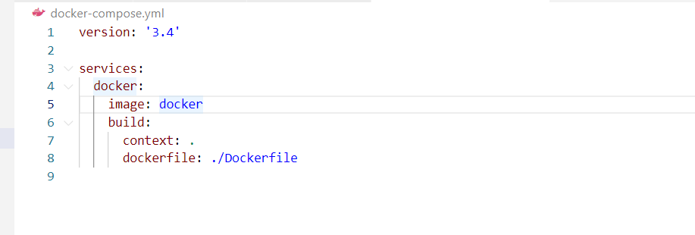

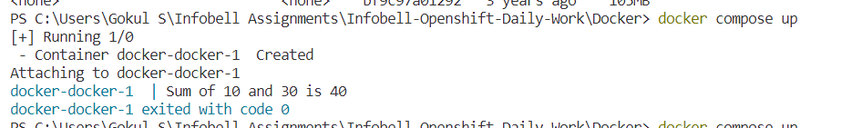

**DOCKER VOLUME CREATED**

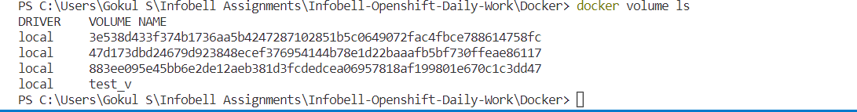

**DOCKER NETWORK**

